Custom Travel and First Aid Packs for Pets
Melissa Shapiro, DVM, Visiting Vet Service, visitingvetservice.com
firstaidpacksforpets.com, firstaidpacks@gmail.com

The Deluxe Custom Travel and First Aid Pack for Pets (and Their People) is a comprehensive kit filled with a variety of first aid items that is based on the pack I keep for my own dogs. The pack is designed for families that travel with their pets, for active dog families that hike and frequent the parks and beaches, and for those that live in areas that are a distance from a vet hospital and pharmacy. The deluxe pack is also a good fit for boarding and training facilities, and grooming shops. It comes with a detailed instruction manual.

The Basic Custom Travel and First Aid Pack for Pets is a complete and practical first aid kit for dogs and cats. It is packed with ample supplies of bandaging materials, cleansers, ointments, tweezers, cold and warm compress, thermometer, and more. It comes with the same manual as the deluxe kit. The basic pack is ideal for active dog families, pet sitters, traveling dog trainers, groomers, canine centers, and for everyday family use, especially on weekends when the regular vet hospital is closed. It is compact and easy to take along when you’re traveling with your pet in the car or on a plane.
The Beach Bandaging Pack is a small pack that contains supplies necessary to take care of minor foot and other superficial injuries in dogs running at the beach, parks, on trails, sidewalks, and hot pool decks. It comes in a small mesh bag or white box with an instruction sheet. It is light and easy to keep in the car or in a backpack. This pack is a necessity for all active dog
families.

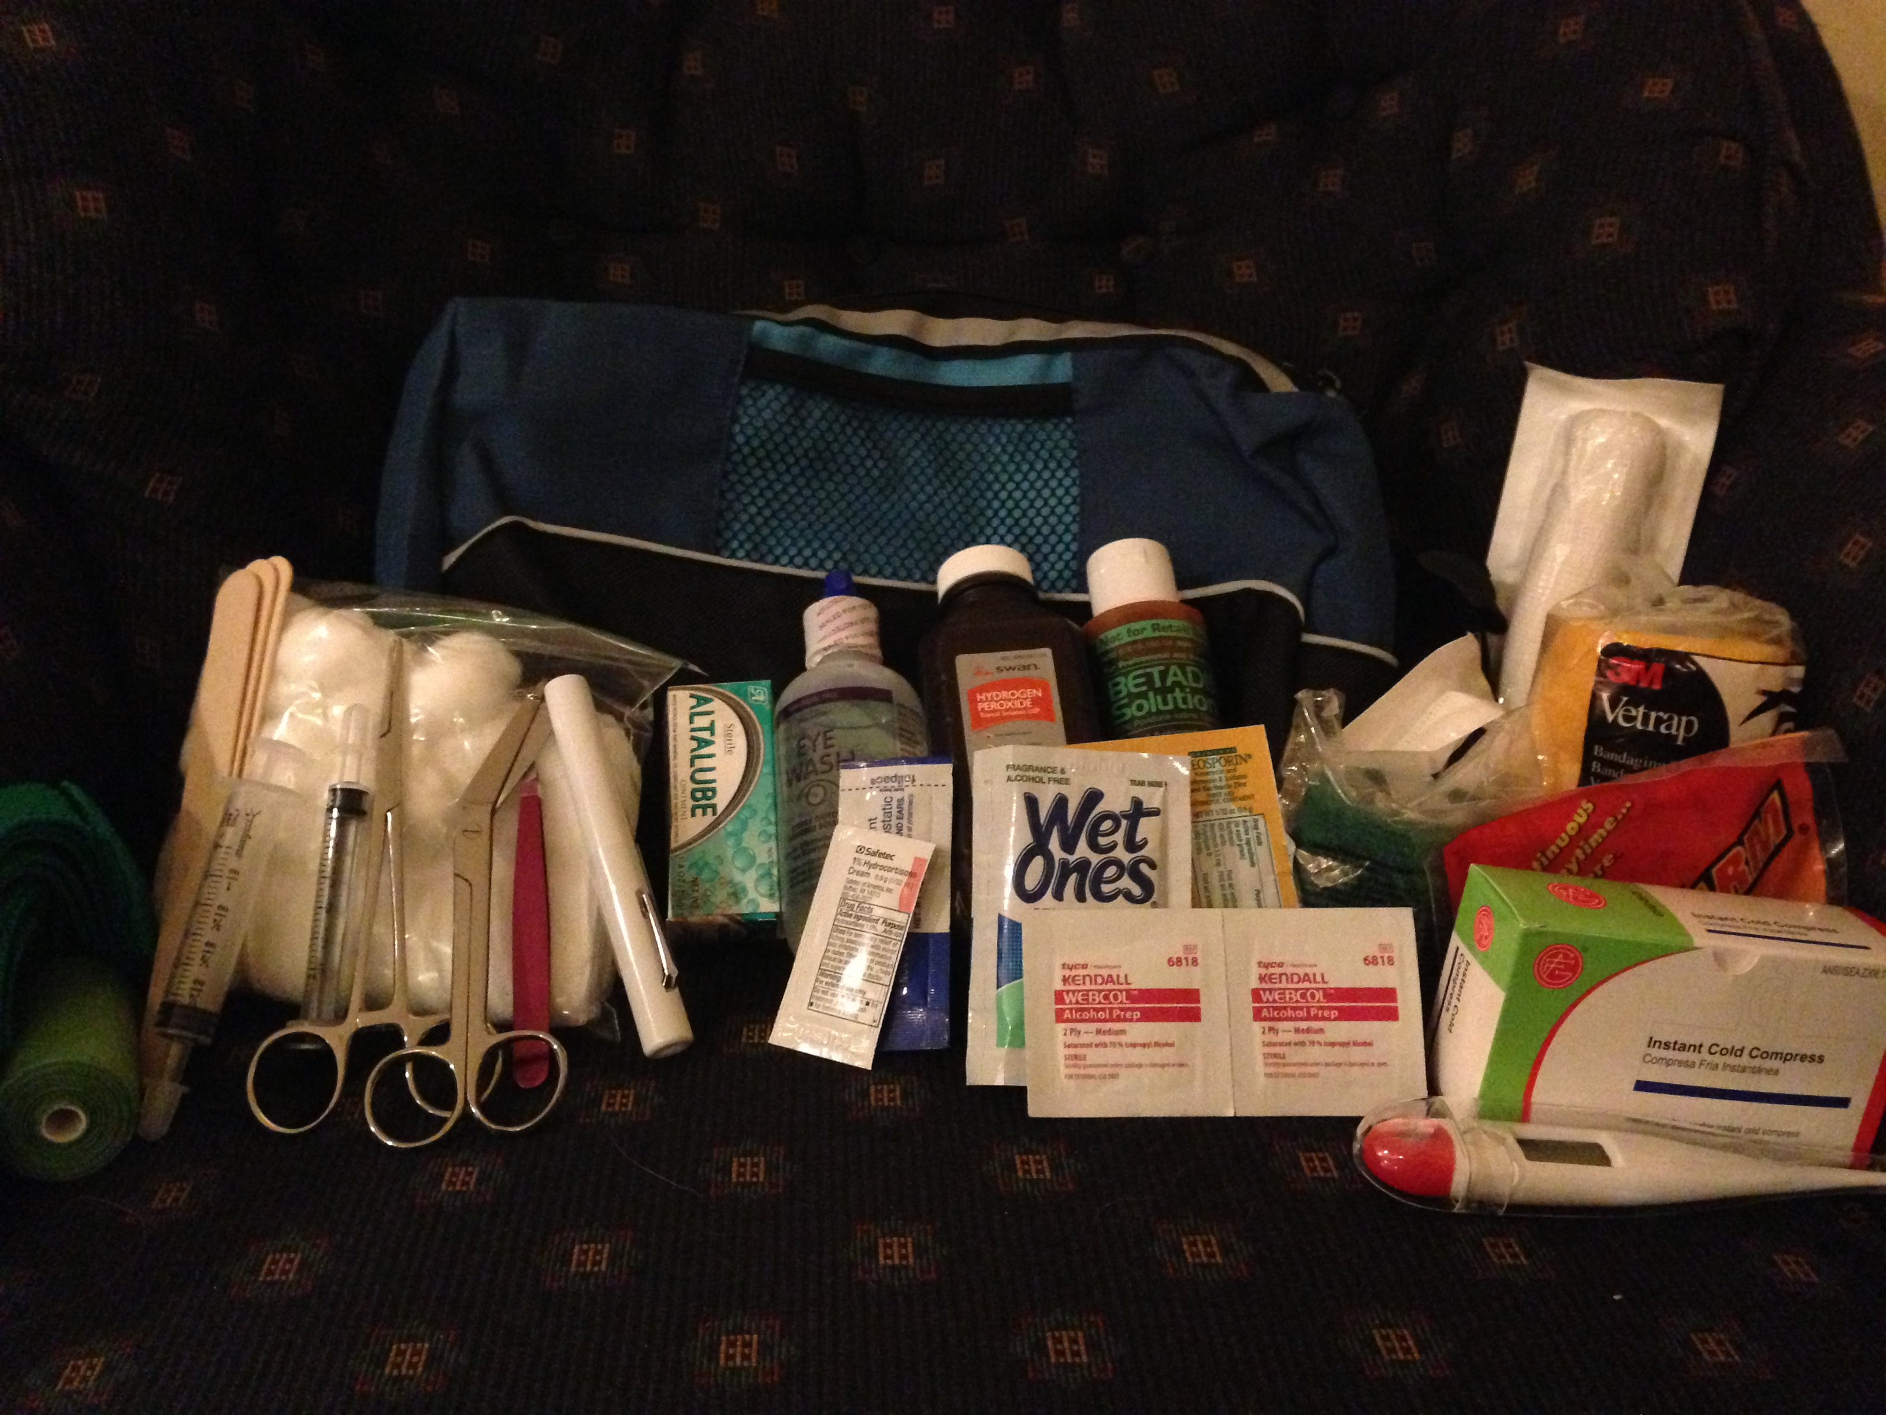
The Bare Essentials Kit for Dogs is a compact kit that addresses the two most common first aid situations dogs are likely to encounter. The kit combines the Beach Bandaging Kit with a supply of fresh hydrogen peroxide and dosing syringes, which can be used to induce vomiting when a dog ingests a toxin. Of course, peroxide can also be used to clean wounds. Detailed instructions are included.

The First Aid Packs for Pets Manual covers practical first aid, general pet care and safety, and has links to important online information such as poison control and pet safety supplies. The manual is included with the Deluxe and Basic packs. It can be purchased separately as well. The manual is updated regularly.

Our packs are packed in high quality plastic boxes, mesh packs, or canvas bags. Since they are custom made, the packaging will vary depending on the supply of interesting bags and boxes.

If you plan to travel with your pet or you won’t have easy access to a veterinary hospital, please inquire about customizing our packs further to suit your own pet’s individual needs. Supplies in all packs can be used for pets AND their people. Learn about first aid for pets and how to use our custom first aid packs at a firstaidpacksforpets.com.

